**320146 Assessment Task 3:**

**Applied Data Visualisation**

Wilcent Wijaya - 14378917

Sample Dataset:

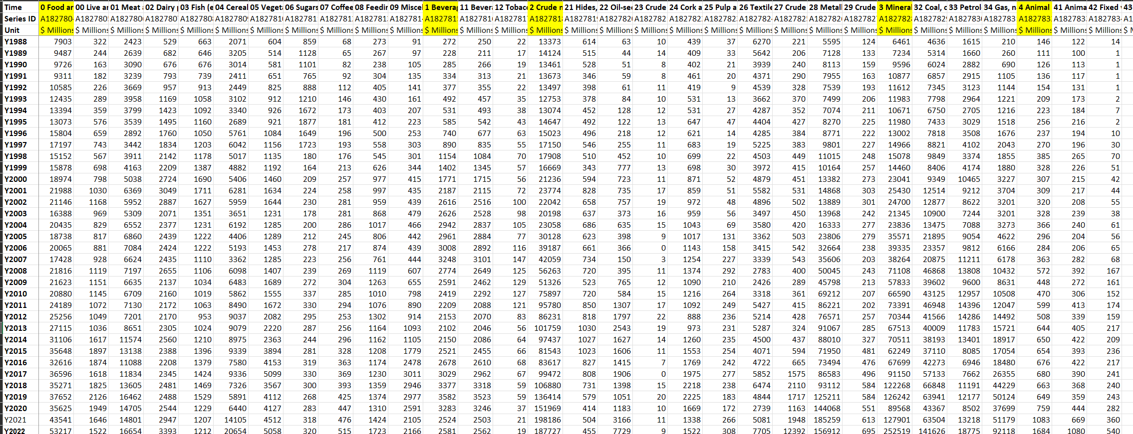

Figure 1

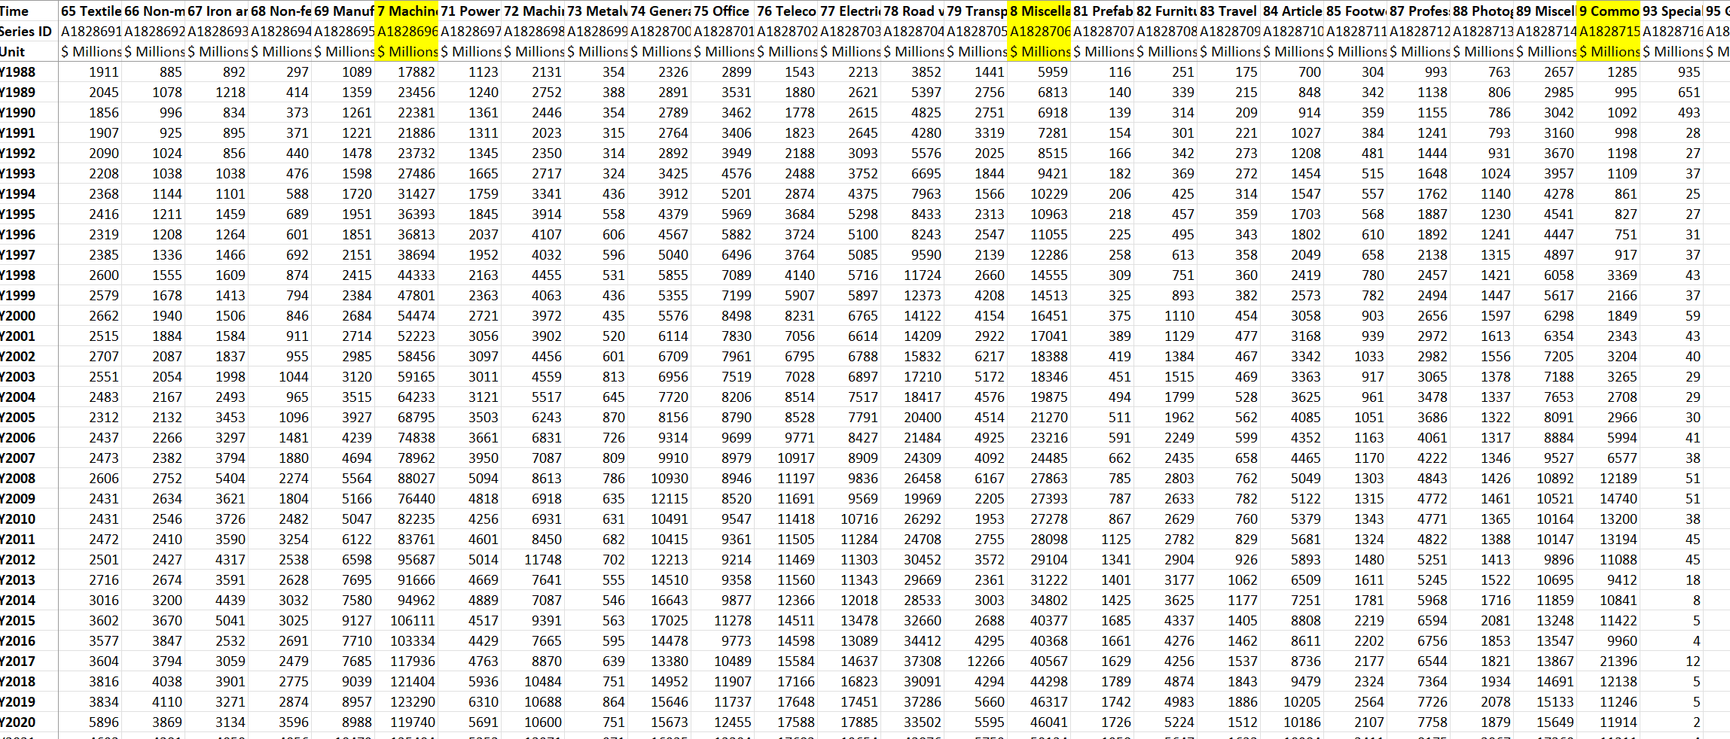

Figure 2

Figure 1 above shows the export data from the Australia International Trade dataset. It contains data from the year 1988 and 2022. Figure 2 above also shows the import data from over 30 years. Each dataset has 10 respective categories which will be analysed and visualized in this report. From the 10 categories there are unique trends and movements regarding the data throughout the years. Both import and export dataset have the same categories which are Food and Live animals, Beverages, Crude Materials, Mineral fuels or Lubricants, Animal and Vegetable oils, Chemical products, Manufactured goods, Machinery and Transport, Miscellaneous, and Commodities and transactions. Each category is accompanied by their respective subcategories for additional detail and information.

Data Preparation:

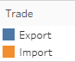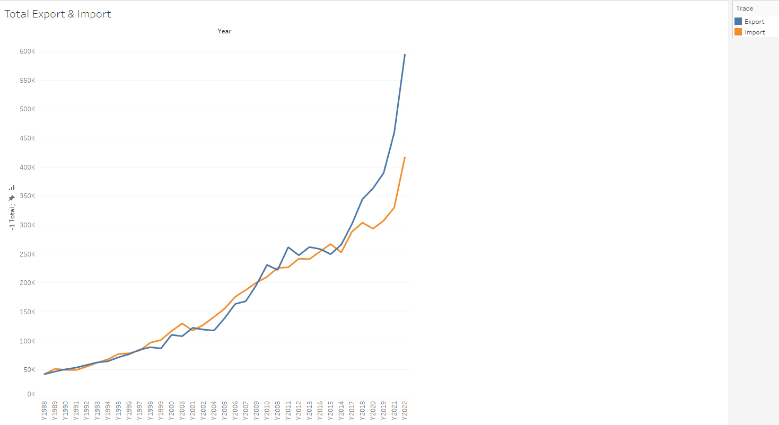

Figure 3

Figure 3 above illustrates the overall total ratio of both import and export data throughout the 30 years which is from 1988 to 2022. Although Export has performed better than import overall, we can see that from the figure above, import data also has increased steadily throughout the years. Furthermore, both import and export experience a significant rise from the year 2019 to 2022.

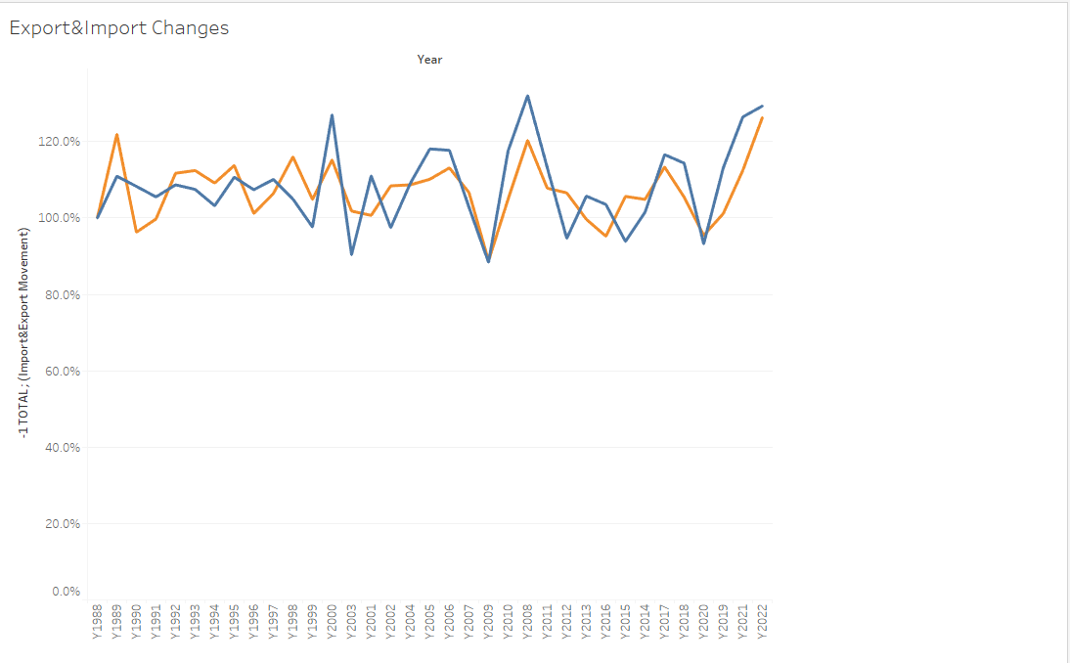

Figure 4

From figure 4 above we can see the overall movement of both export and import data. We can see that export has experience a more volatile change. The export data illustrates the significant rises and fall on each point in time. Similarly, the import data also illustrates similar things, however the import data has a slightly less increase and decrease throughout the years. Notably, in the year 2022, both import and export data experience a rise in changes.

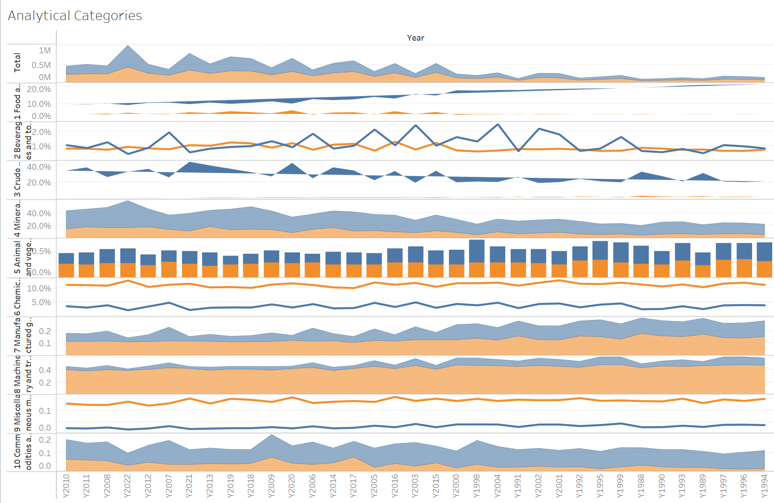

Figure 5

Figure 5 illustrates the changes of each major categories from the 10 main categories from both export and import dataset. The figure above utilizes Area chart, Line chart, Bar chart, and Polygon chart. Bar chart is used in the figure for easy readability and interpretation for the readers. Line chart allows to illustrate the trends that are in the figure. Area chart are suitable for displaying cumulative data and visualizing proportions between data. Polygon chart allows comparison between multivariate data and also visualizing profiles of variables. Figure 5 is the Analytical visualization data which allows the analyzation of the movement of both import and export data.

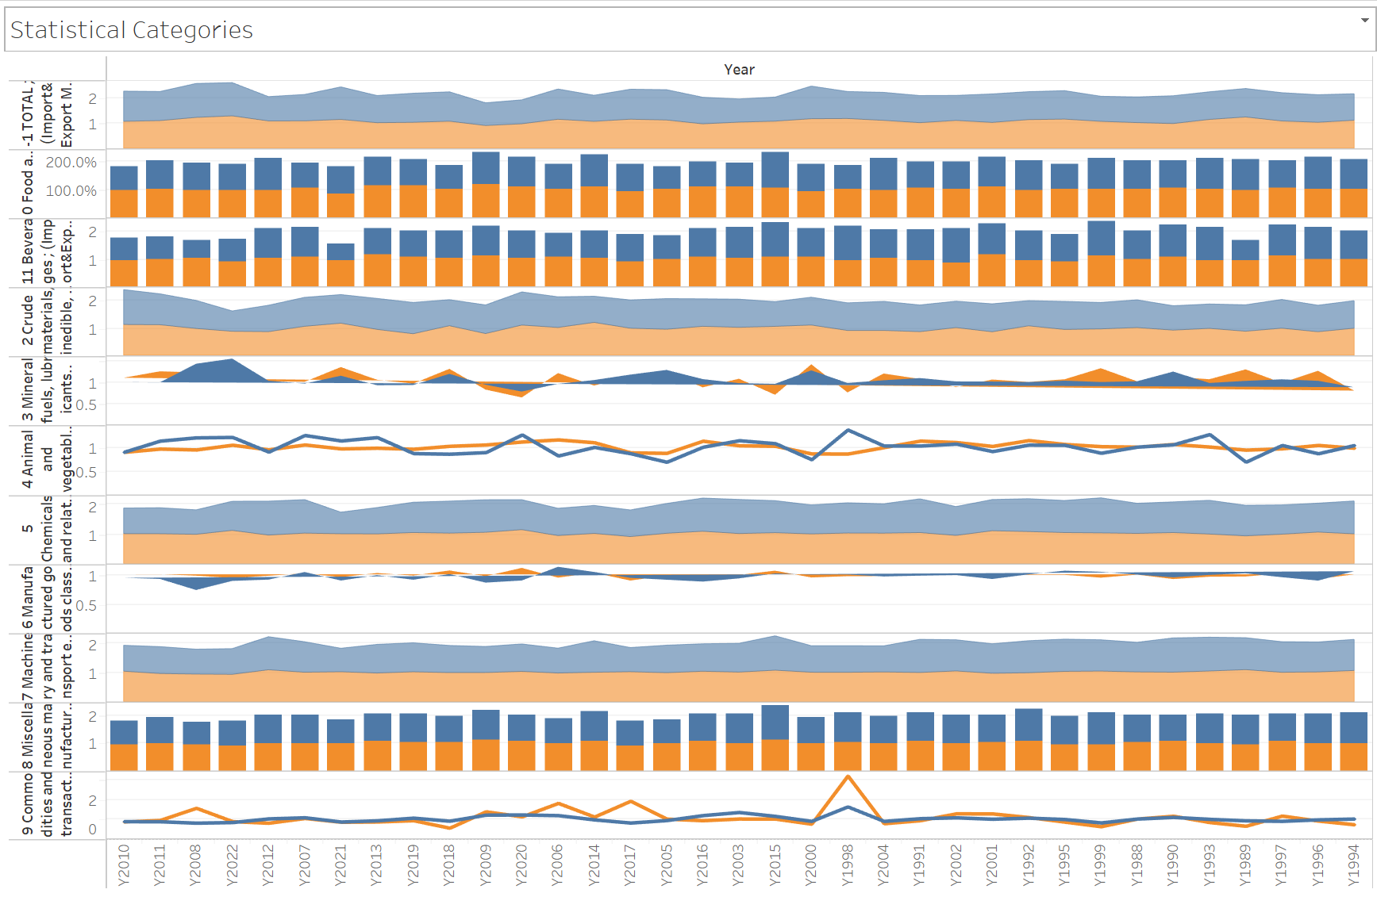

Figure 6

Figure 6 above is the Statistical visualization of the 10 respective main categories. The Statistical visualization describes the changes in ratio from both import and export data. The figure above utilizes Area chart, Line chart, Bar chart, and Polygon chart. Bar chart is used in the figure for easy readability and interpretation for the readers. Line chart allows to illustrate the trends that are in the figure. Area chart are suitable for displaying cumulative data and visualizing proportions between data. Polygon chart allows comparison between multivariate data and also visualizing profiles of variables.

# Import Data Time Series Charts

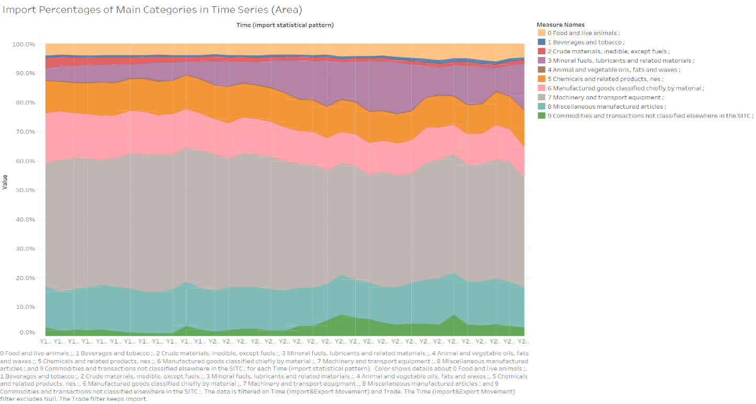

Figure 7

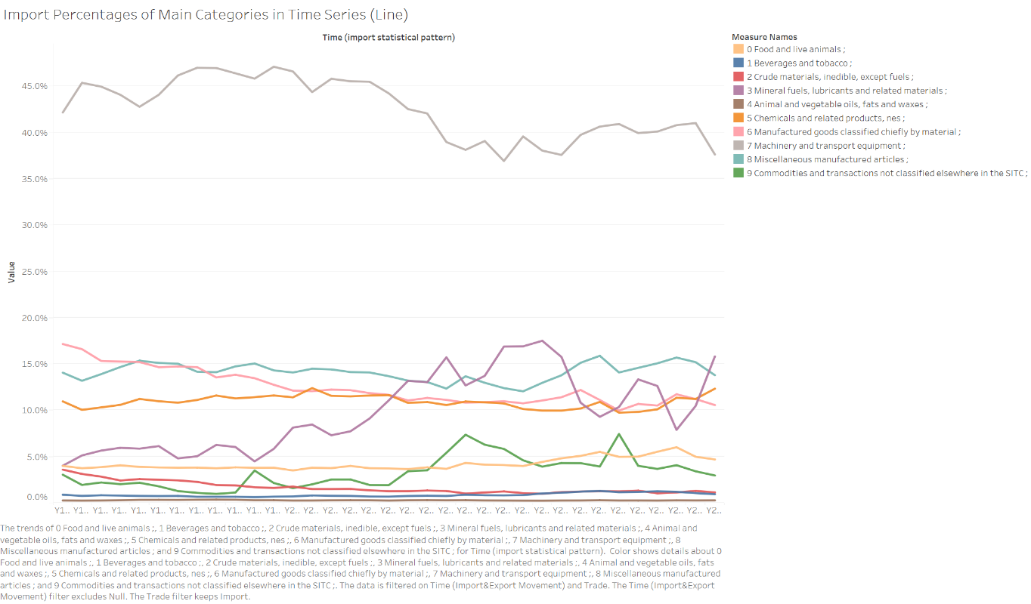

Figure 8

Figure 7 and Figure 8 both illustrates the import data throughout the years of the 10 main categories. Figure 7 visualizes the import data in an area chart format which is suitable for displaying cumulative data, each area is assigned with different colours in order for easy readability. Furthermore, area chart also visualizes the values or proportions of specified variables in the dataset while also comparing between data. From Figure 7, we can see that Machinery are the most imported category in comparison to other categories throughout the years consistently. Compared to other categories, Figure 8 concludes that Machinery significantly outperforms the other categories since the line represented are located on a whole different area on the chart. From both Figure 7 and Figure 8, it is clear that the least imported category throughout the year is the Animal category since it has been consistently stayed at below 1% from the year 1988 to the year 2022.

# Export Data Time Series Charts

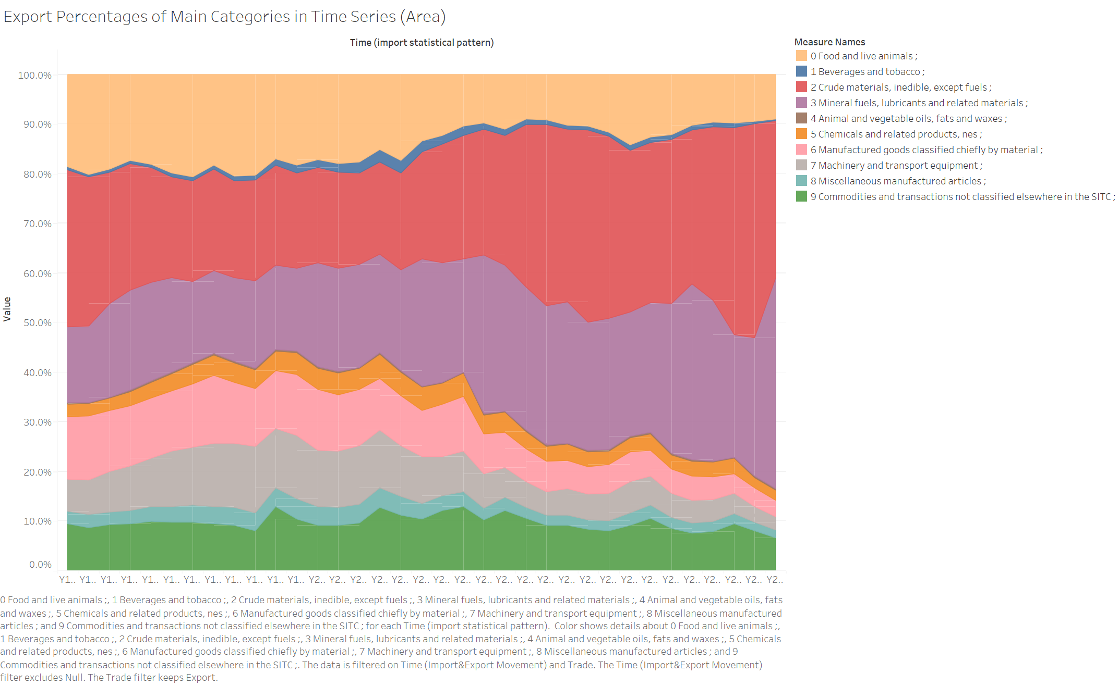

Figure 9

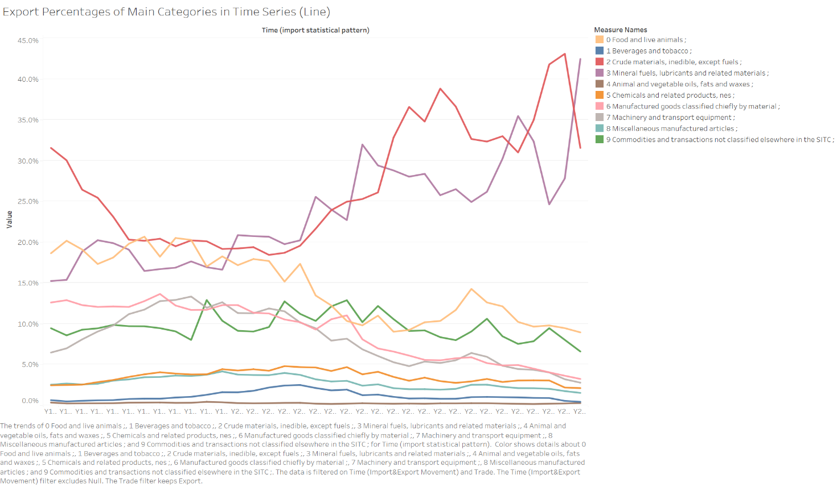

Figure 10

Figure 9 and Figure 10 both illustrates the export data throughout the years of the 10 main categories. Figure 9 visualizes the import data in an area chart format which is suitable for displaying cumulative data, each area is assigned with different colours in order for easy readability. Furthermore, area chart also visualizes the values or proportions of specified variables in the dataset while also comparing between data. From Figure 9, we can see that both Crude Materials category and Mineral Fuels category are the most imported categories in comparison to other categories throughout the years consistently. Compared to other categories, Figure 10 concludes that both Crude Materials category and Mineral Fuels category significantly outperforms the other categories since both lines experienced quite the spike from the last 10 years. Similarly, from both Figure 9 and Figure 10 it is clear that the least imported category throughout the year is the Animal category since it has been consistently stayed at below 1% from the year 1988 to the year 2022.

# Interactive Chart (Bubble Chart)

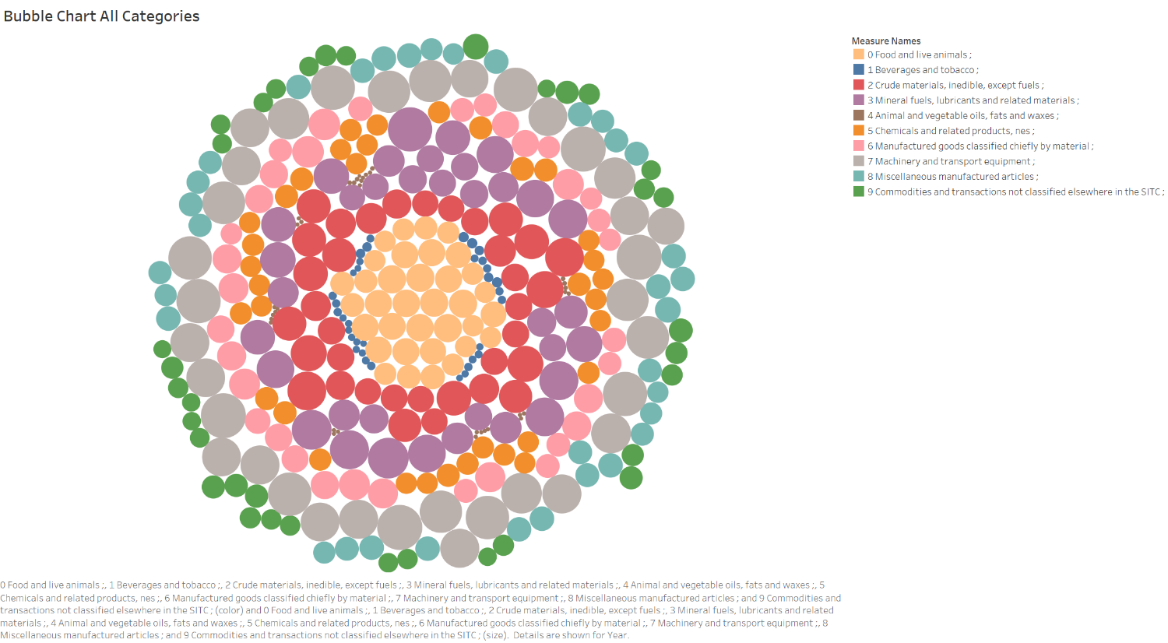

Figure 11

Figure 11 above visualizes the 10 main categories in small packed bubbles. Each category is assigned a colour followed by its value as its size. The size of each bubble varies since each bubbles represent different values and different categories at a different time. The bubble chart in figure 11 is formatted following each category, starting with Food and Live animal’s category as the first, which located in the inner most part of the chart. Bubble chart are one of the best interactive charts since it allows different way of data interpretation. Furthermore, bubble chart allows readers to interact with the data in the chart and explore different factors of the data visually.

# Category 3 Visual Dashboard (Mineral Fuels)

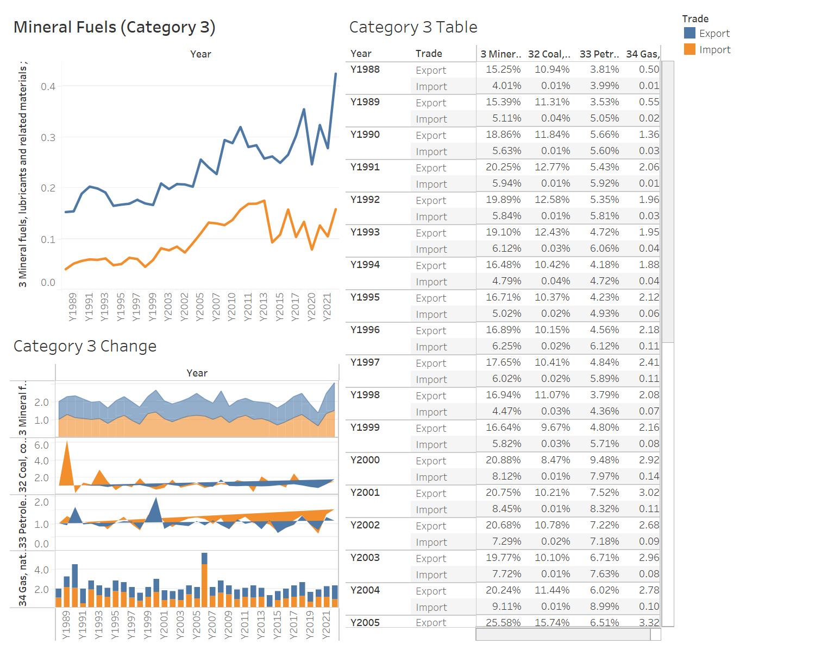

Figure 12

Figure 12 display a visual dashboard for category 3 which is Mineral fuels. From the visual dashboard we can see that there are 3 different charts or factors. The dashboard is made up of a line chart, polygon chart, bar chart, and a data table for each year. The line chart illustrates the overall change throughout the year for category 3 specifically. The sub category charts are represented on figure 12 below the line chart. Followed by the category 3 table which contain the data for each sub category throughout each year.

Data Storytelling: Visual Storyboard

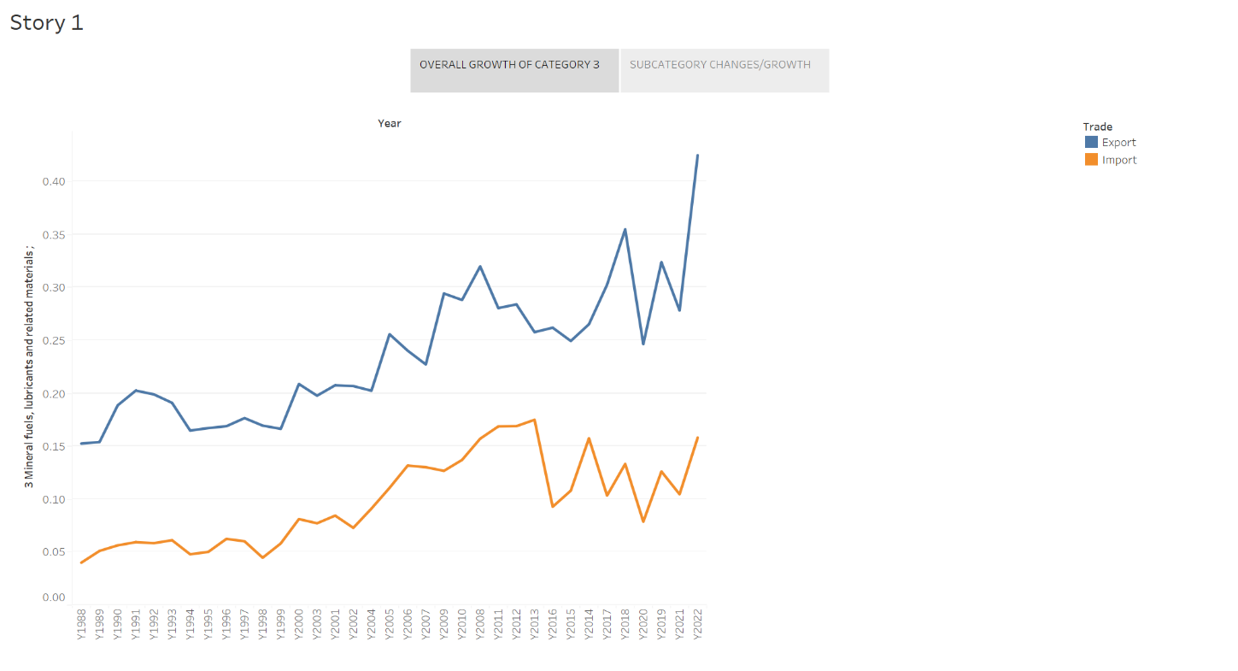

Figure 13

The first story point in figure 13 is the overall growth of category 3 which is the export and import of Mineral Fuels. From figure 13 we can see that from the year 2021 to 2022 there was a significant spike of over 0.2 which is almost half from the previous year. However, from the import section, there seems to be stagnant growth from the year 2013 to 2022. The huge spike of export in mineral fuels could be due to the uplift of restrictions from the previous epidemic that happen in 2021.

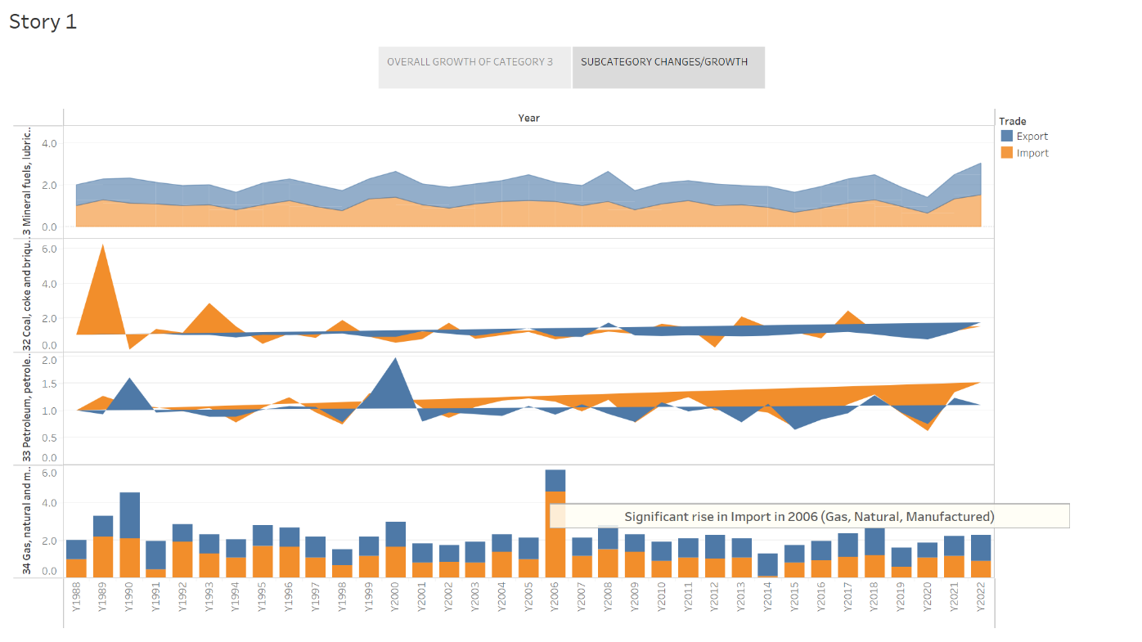

Figure 14

Figure 14 illustrates the second Story point which shows the overall growth of the sub categories of category 3. The most notable occurrence was the sudden significant spike of import in the year 2006 in the sub category of Gas, Natural, and Manufactured goods. The other 3 sub categories however, only experience a slight growth throughout the years.

# Findings and Recommendation

From the various visualization techniques used throughout this report, there has been a few trends and growth spotted throughout the years from the 30-year dataset. Most notably is the huge growth of both the export and import side of the Australian Trade. Throughout the years the Machinery category has been hugely imported consistently which shows that the demand for the machinery equipment in Australia has been growing steadily and with no sign of decreasing. On the other hand, Australia also has the least Animal, Vegetable oils imported throughout the year which shows that Australia most likely don’t rely on other countries in that category. From the dataset we concluded that Australia has been exporting Crude materials and Mineral fuels mostly in comparison to the other main categories, this could impact the environment negatively and could possibly lead to overreliance on a specific resource which is not renewable and sustainable. Overall, we recommend that exporting other categories that are more sustainable and renewable will be more optimal for Australia in order to avoid negative impact to the environment and economic dependence.